Overview

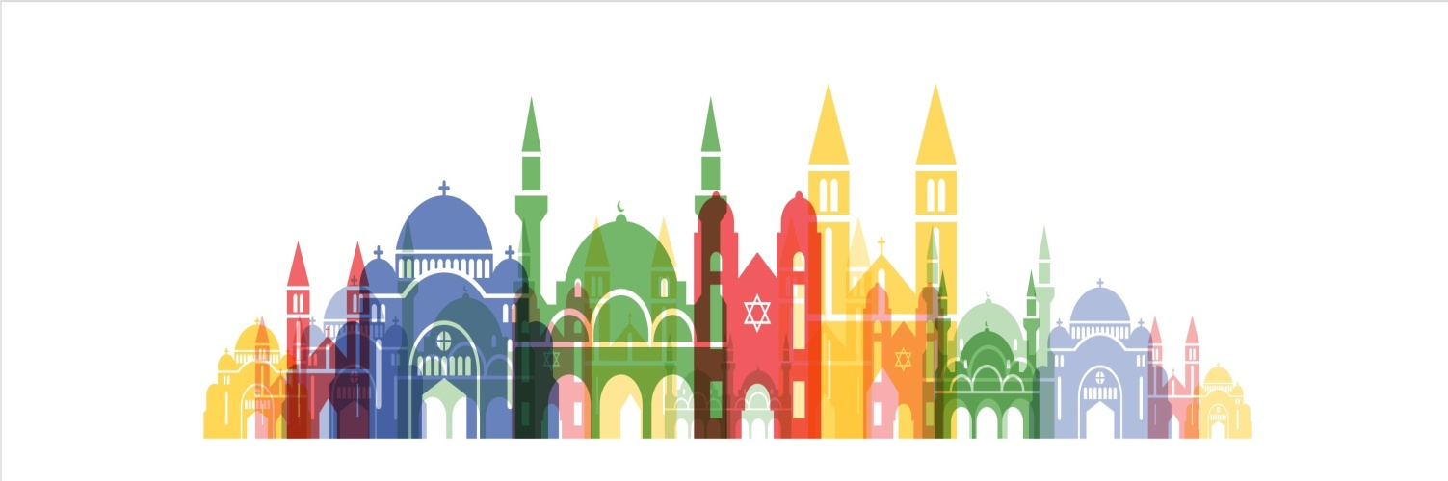
INTER-RELIGIOUS COUNCIL
IN BOSNIA AND HERZEGOVINA

Sarajevo, November 2021

Short background of the organization
The Interreligious Council in Bosnia and Herzegovina (IRC BiH) was established in 1997 by a joint agreement between leaders of the traditional churches and religious communities of the four main traditional religions in the country (Islamic Community in BiH, Serbian Orthodox Church, Roman Catholic Church, and Jewish Community in BiH). After the devastating war in Bosnia, the organization made a great step toward building peace and development of the civil society with the idea of reconciliation among the BiH peoples. At that time the IRC BiH exceeded all obstacles caused by the situation of a complete deconstruction in the material and moral sense and endless hatred caused by the war, as well as abuse of religion resulting from atheism and banishment of God. Through this reconciliation process started a successful voyage in building civil society through interreligious dialogue.
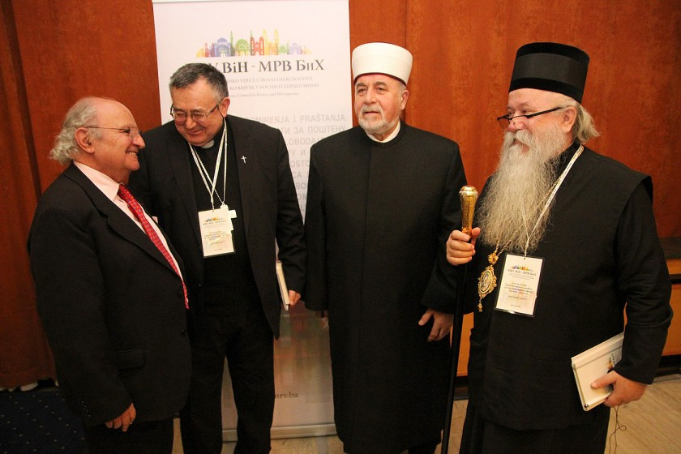
Members of the IRC Assembly: religious leaders of 4 traditional faiths in Bosnia and Herzegovina

The IRC BiH is organized according to the principle of a non-governmental organization, and it is a specific body in many ways. This implies the equal involvement of churches and religious communities that exist for centuries in BiH, as well as organizational and communication complexity through which representatives of different religions act and communicate in the same direction, while communicating equivalent messages.

Through 24 years of its work, the IRC both lead or participated as a partner in numerous projects targeting local communities, aimed at building tolerance and civil society in the country, but also expanding their work and show-hows in the region. When the IRC BiH was established, it was the only organization of such kind in the world holding this particular name, and today there are over 120, however, without such wide-ranging programs. IRC BiH name became a brand and synonym for a success story first in the country then in the region and beyond.

IRC structure and the principle of work
The Assembly of the IRC consists of the highest religious leaders of the Islamic Community, the Serbian Orthodox Church, the Catholic Church and the Jewish Community in BiH. Presidency of the Council functions on an annual rotating system.
The Executive Board functions composed of four members appointed by the religious leaders. The Board meets at least once a month and they make decisions in coordination with the Secretariat concerning project activities and complex administrative matters of the IRC office.
The IRC Secretariat in Sarajevo has staff members, who coordinating projects, day-to-day activities and the office, communicating between international and national agencies and the higher level of the organization, managing and coordinating activities in the field with Interreligious local chapters, or regionally with representatives of religious communities from the neighboring countries.
Intererreligious local chapters are established in 15 municipalities all over Bosnia in an effort to replicate interreligious dialogue and action at the grassroots level. Representatives of different religious communities together with their members and volunteers meet regularly to plan interreligious events to bring the community together, to address the incidents of prejudice or violence based on religion, coordinate activities promoting cultural and religious heritage, projects aiming women believers, youth, etc. There are countless potential to work in their respective communities to improve the social context in which they can advance their living. Each chapter has its own way of operating, however set by the rules on the higher levels. The Chapters submit their monthly report to the Secretariat.
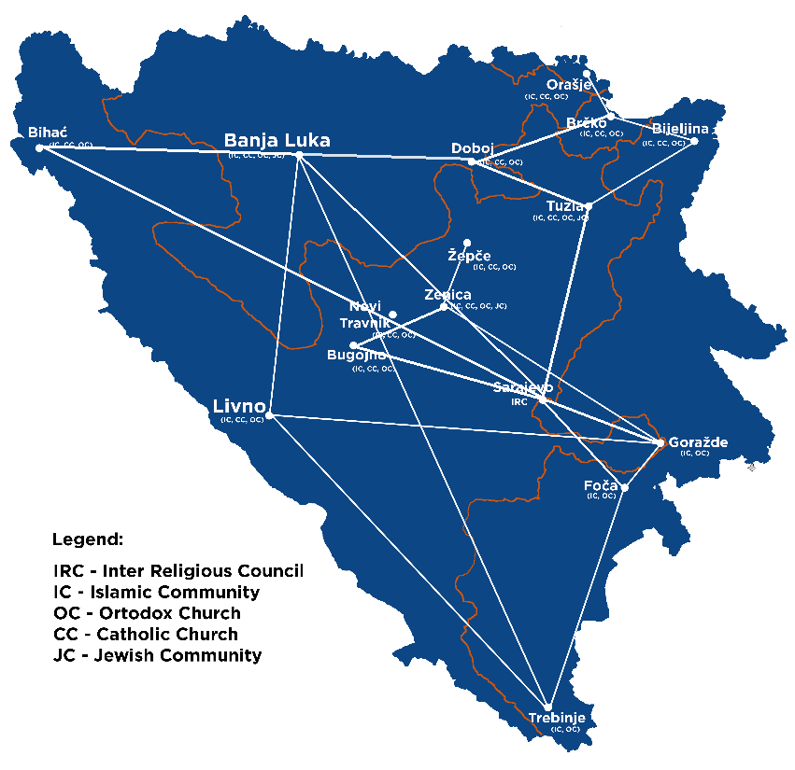
Map of Bosnia with locations of the Interreligious local chapters and their usual networking

By strengthening the interreligious local chapters, IRC BiH wanted to bring ordinary people to actively participate in the work of Council, so that people in local communities intensify their joint and common activities. Local community activities should be the reflection of what was designed on higher IRC levels and the idea to network them into local chapters proved to be an excellent way of operating. There are 15 of them and the plan is to expand the network to some other locations/municipalities that already expressed their willingness to work for reconciliation through IRD (interreligious dialogue).

Projects and Partners

The Interreligious Council in BiH develops and implement projects of high interest for the Bosnian people, aimed at reconciliation and building and maintaining peace to attain better and more humane society for all people in the country. The idea is to work at national but also regional level, and to network of local chapters with different types of programs. These programs were developed in cooperation with national institutions, international organizations and civil society partners, who provide their support where possible. The following are some of the projects implemented by the IRC BiH:

MONITORING ATTACKS ON RELIGIOUS SITES AND PLACES OF WORSHIP AND OTHER PLACES OF IMPORTANCE FOR RELIGIOUS COMMUNITIES IN BIH

The main goal is to provide better protection of religious sites and to raise awareness in local communities about importance of condemnation of acts of hatred and intolerance to the Other. In Bosnia and Herzegovina, there are many places were one religious community is majority and predominant and minorities are always vulnerable, especially in times of politically heated debates and issues, and, of course, elections. Almost every project that IRC implements, covers the aspect of prevention of attacks, as well as their condemnation when these highly unpleasant incidents occur. The IRC BiH has established a record of attacks on religious objects and it undertakes analysis of collected data in terms of: the ways of attack, attack motives, whether the offender is convicted, the area in which they carry out attacks and others.
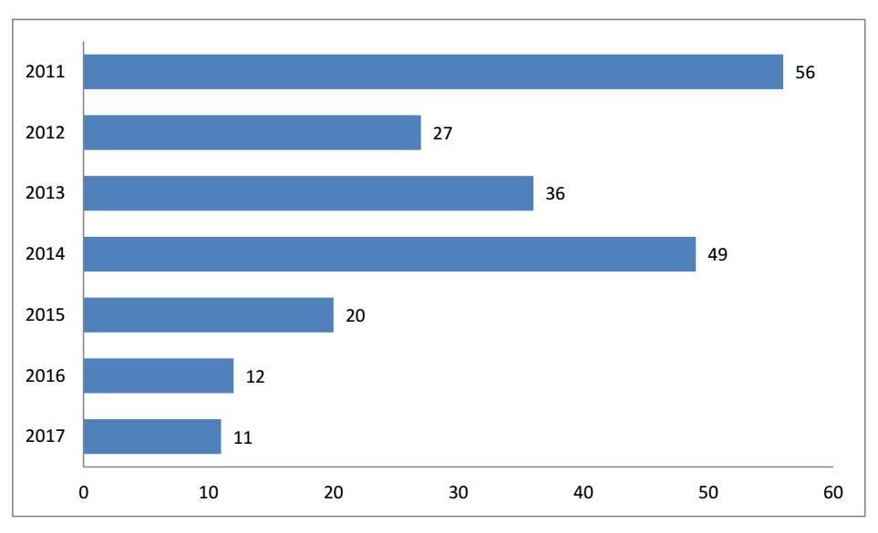
Number of attacks on religious sites in Bosnia by years
Interreligious Council in Bosnia and Herzegovina lobbies that attacks on religious sites should be treated as a crime of inciting religious and ethnic hatred in accordance with the Criminal Code of FBiH and RS, if the facts indicate that the incident is committed out of hate.
The IRC adopted and practice response in a manner that members of Local Chapters’ board (if the attack occurred in the municipalities where a Local Chapter is present), composed of local representatives of religious communities, local authorities and other competent institutions, come together to the sites and speak to the media condemning the attack with a call for tolerance. This practice proved to yield results, as religious leaders do have high authority among local population and their appeals bear importance.

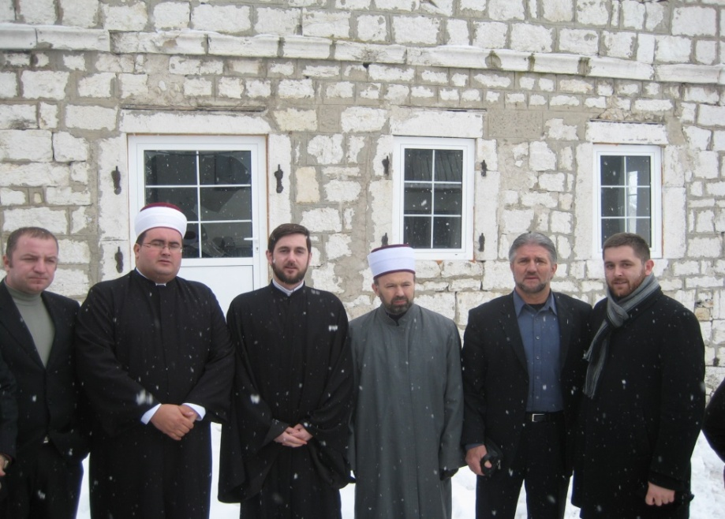
Members of Local chapter in Livno, condemning publicly attack on a religious facility.

PRESERVATION OF PEACE THROUGH BUILDING TRUST AND RECONCILIATION
In this project, currently in its fourth year of implementation, supported by UNFPA and the British Embassy, the IRC BiH has achieved pioneer results on global level. The focus was maintained on persons who survived sexual violence and trauma in the previous war, who were given support through different programs, in terms of psychological, social and economic assistance. However, the main highlight was removing stigma that the surroundings built toward the victims, manifested in their local community, society in general and even their families. For that purpose, leaders of four main religions, members of the IRC assembly, came up with a Declaration on Eliminating Stigma Toward Persons who Survived Sexual Violence in the Previous War. This was the first declaration of that kind signed by religious leaders, calling to prevent sexual violence in conflict and denounce the stigma faced by survivors, including children born of sexual violence, securing participation of religious communities in giving active support needed to the victims, primarily psychosocial support.
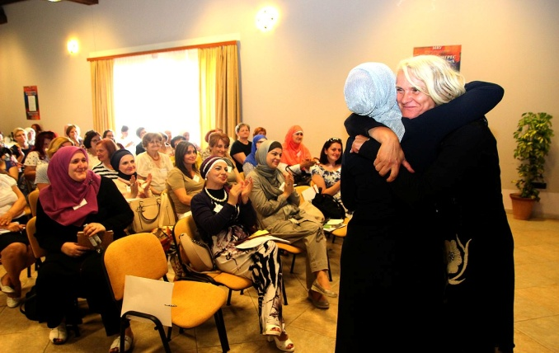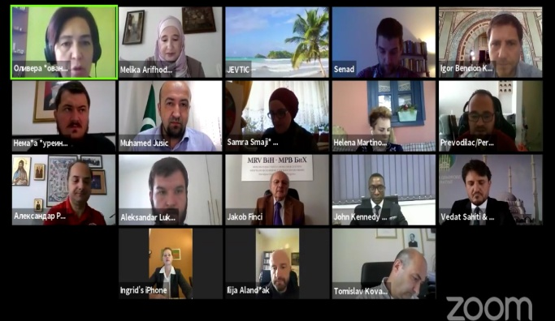
Picture 1: Giving support to victims of sexual violence through round tables and testimonies
Picture 2: Representatives of religious communities from Serbia, Bosnia, Croatia and Kosovo* forming a Project Working Group, during the session where the implementation of Action Plan was discussed

The Declaration was later supported by religious communities and churches from the region (Serbia, Croatia and Kosovo*), and the support went even further – adopting Regional plan of Action, following principles and directives set out in the UN Plan of Action for Religious Leaders and Actors to Prevent Incitement to Violence that Could Lead to Atrocity Crimes. The Council was honored by the visit of Mr. Adama Dieng, Special Advisor on the Secretary-General on the Prevention of Genocide where the IRC BiH members had opportunity to present their Action Plan that actually localized and followed the guidelines in the UN Plan of Action.
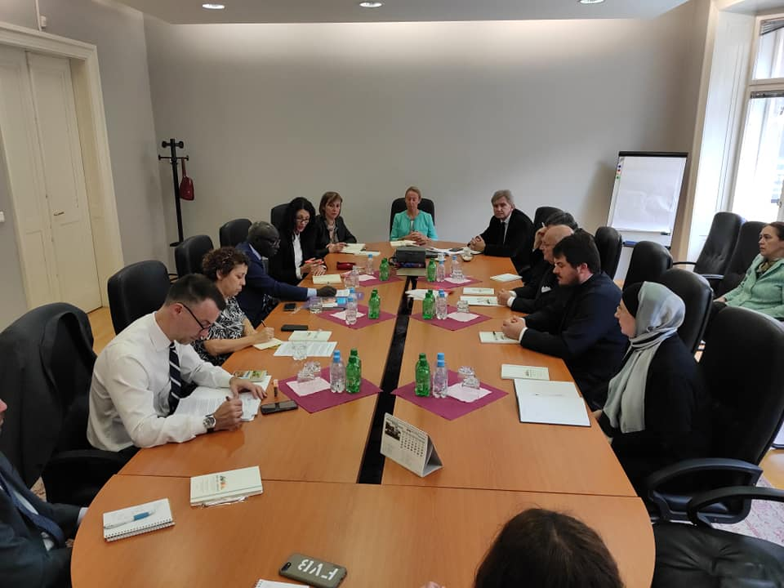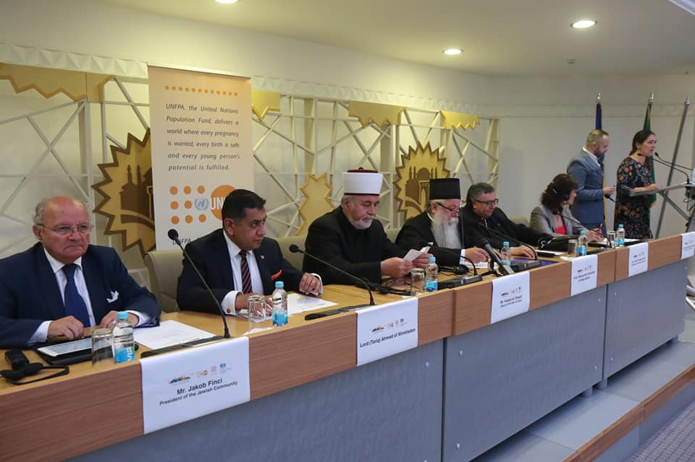
Picture 1: Mr. Adama Dieng and UN and IRC BiH representatives, during his visit, discussing the Action Plan
Picutre 2: Visit of Lord Ahmad of Wimbledon to the IRC BiH, attending the Project conference

Lord Ahmad of Wimbledon, representative of the British PM for the matters of prevention of sexual violence, and British Minister for human rights, also visited the IRC BiH last year when he participated in conference within the project. The IRC BiH is proud by the fact that Lord Ahmad, inspired by the IRC BiH Declaration on Eliminating Stigma on Persons who Suffered Sexual Violence in the Previous War , initiated Declaration on Humanity by Leaders of Faith and Leaders of Belief, which is signed recently, on 17 November 2020.
The IRC is in the process of securing funds for the implementation of the Action Plan that was the result of this Project.

RELIGIOUS LEADERS AND YOUTH AGAINST THE HATE SPEECH
The project has just finished, and it was supported by the USAID and IOM. It gathered religious leaders from local communities and youth from 5 cities in Bosnia and Herzegovina, to fight against the hate speech that is present in public sphere, and particularly in social media and Internet.
In the project it was planned that IRC BiH comes out with a strategic and more aggressive counter-narrative to these public hate speeches that became something that citizens, especially young people, are regularly facing with many of them taking as something normal. The leaders and youth went through trainings for creating positive narratives and could have their contents (texts, articles, photographs and videos), posted on the IRC official accounts and pages. At the same time, IRC Youth Network was built with young people prepared to get more involved into IRD and be proactive in shaping the public space in the country.
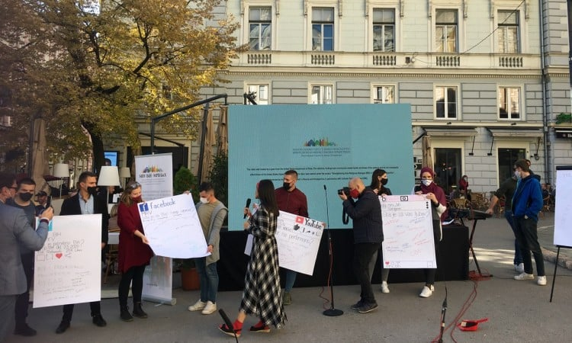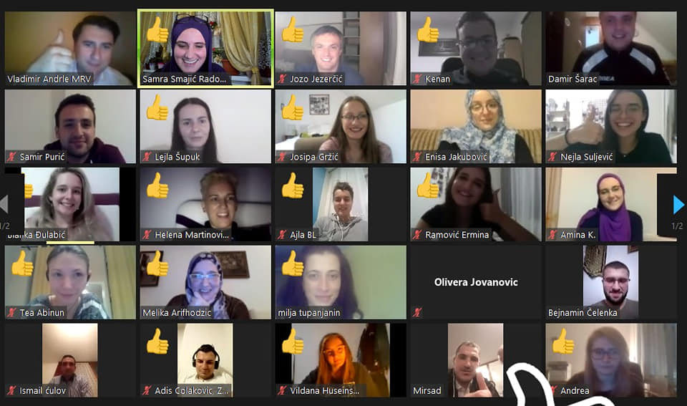
Picture 1: Public performance about need of spreading positive narrative opposing negative one
Picture 2: Voting for adopting principles and rules for the Youth Network

The young people in the project had opportunity to participate in public performances calling citizens, especially young people to stop hate speech on social network and to have consideration toward the Other. Although the pandemic did not allow as many participants as it was planned, it was still well attended and, thanks to the modern technology, available for watching online.
During the establishment Assembly of the Youth network, youth officially adopted their network’s principles and declarations. The young people of different religions and ethnicities showed incredible enthusiasm and willingness to work together in future for better society for themselves and other citizens.

Some of other projects, activities and achievements:
Women of Faith Network – was established gathering women of all faiths in Bosnia and organizing general Conferences. In these gathering, women agree which topics and segments of IRD, or other related aspect should be taken into account in future IRC activities. WFN gives a strong support to any project that involves women and that works on empowering or making the position in the society more respected and accepted. WFN organizes from time to time Round table for women, discussing topics and issues relating to their role in the society, religious communities and family.
Visiting houses of worships - is a very popular activity where young people, but often also mature citizens, of diverse faiths, visit different religious sites where they learn about teachings and practices of certain religion. Participants get opportunity to ask questions that usually would not pose and feel very comfortable knowing that they came into different religious sites in an organized manner where someone is welcoming them. The surveys show high percentages of answers expressing changed attitudes in a positive way toward different religion.
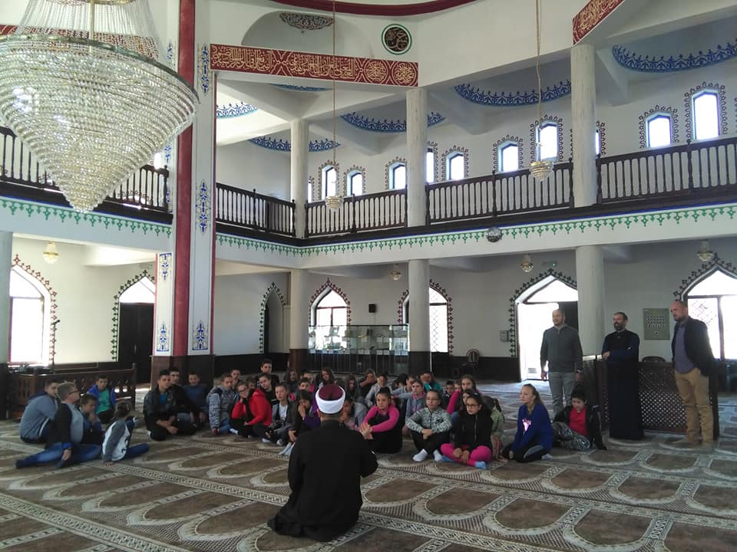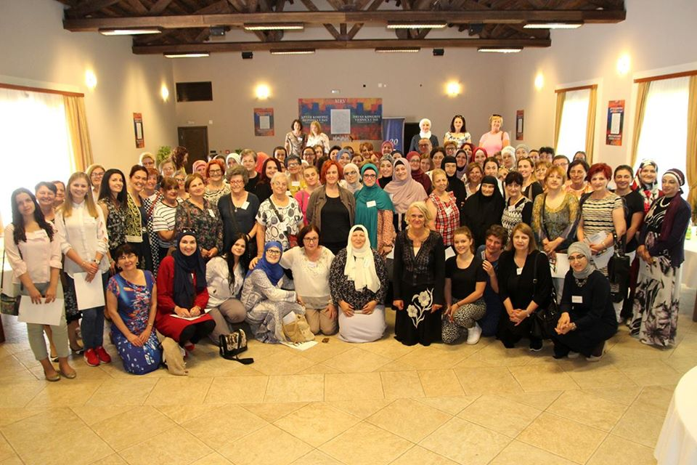
Picture 1: Young people participating visits to different religious facilities where they learn new things
Picture 2: 2nd Conference of IRC Women of Faith Network
Law on freedom of religion - was finally adopted in Bosnia and Herzegovina in 2004, and the IRC was actively involved in its composition through suggestions and comments. The IRC formed a Legal group that monitored the implementation of this law in the years to follow.

Youth summits – this activity was implemented several times as a part of different projects but also as a preparatory activity for the establishment of Youth Network. At this occasions, youth from all over the country gathered in camps, seminars or conferences, to socialize and talk about the topics that are relevant to them and their future.

Common visits to the places of wars sufferings – as well as joint prayers for the victims of war is activity that always gathers a lot of public and media attention in the country and get positive feedbacks. The politicians and officials in the country still did not manage to gather together to pay respect to the victims, but the IRC BiH religious leaders did it on several occasions. During the project that was supported by Rennovabis, Common visits to the places of wars sufferings, religious leaders even went together to the places where atrocities happened to pray for victims’ soul and pay respect.

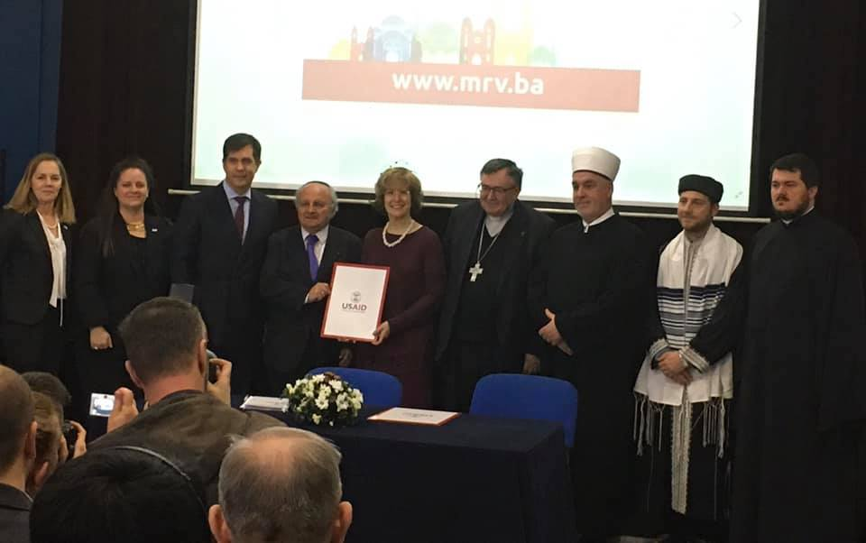
Religious leaders of Islamic community, Orthodox Church, Catholic Church, Jewish Community with guest Mrs. Bonnie Glick and the US Ambassador Mr. Nelson in a joint prayer for all innocent victims of the war
Very often, for different occasions and circumstances, the IRC BiH religious leaders come out with joint statements. The IRC BiH organizes interreligious conferences as well as encounters with relevant organizations and institutions from all over the world. Although the IRC does not produce periodical publications, there are content that are publicized as parts of project, conferences or particular purposes or events, such as publications for teachers for religious education publications, blind persons, publications on customs and traditions in monotheistic religions in Bosnia and Herzegovina, Glossary of Religious Terms, etc.

In addition to this, the IRC BiH organized various seminars for citizens in local communities, youth, women, religious ministers, religious educators and young theologians. With many projects and by creating positive narratives, the IRC BiH has become the leader in the field of interreligious dialogue and the main promoter of peace and coexistence in country and the region.

There are many interreligious councils in the world today, but the first time this name was used in Bosnia and Herzegovina, just after the war, when the four religious leaders marked the beginning of an incredible journey from deconstruction to reconstruction of civil society through interreligious dialogue. By inviting and gathering representatives of all religious communities and churches, employing their infrastructure and resources, the IRC devotedly works on overcoming wounds from the last war, building trust among people, respect, relying to universal values common for every human being.

